Caitlan Nichols  
14 June 2024

Module 3.2 - Normalized tables

(These are notes that I did, the charts are at the bottom. Just incase I did something wrong and you can point it out to me.)  
Unnormalized Data:

- publisher_name

- publisher_ID

- publisher_address

- book_isbn

- book_name

- book_price

- author_first_name

- author_last_name

- author_phone

- author_email

- publisher_email

- author_address

1NF:

single value for each record.

Step 3: 2NF (Second Normal Form)

Table naming and identifying

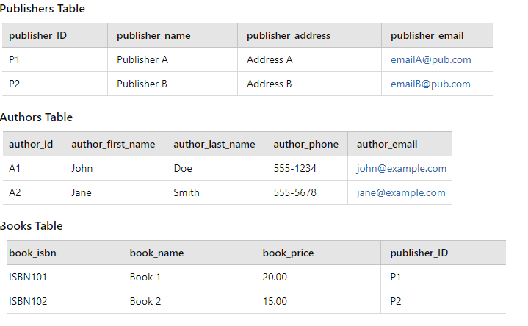

### Step 4: 3NF (Third Normal Form)

Additional things, cleaning up, and to ensure that non-key attributes depend only on the primary key.

Publishers Table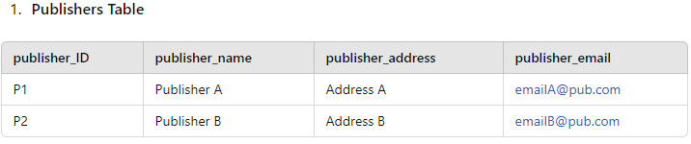

Authors Table

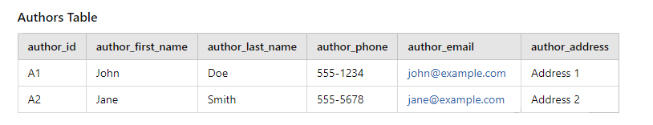

Books Table

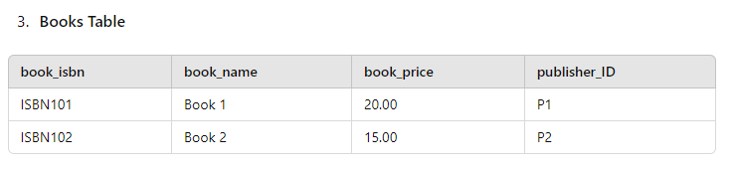

BookAuthors Table

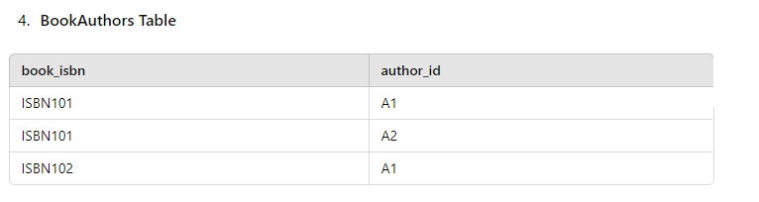

The overall Final Structure in 3NF table building

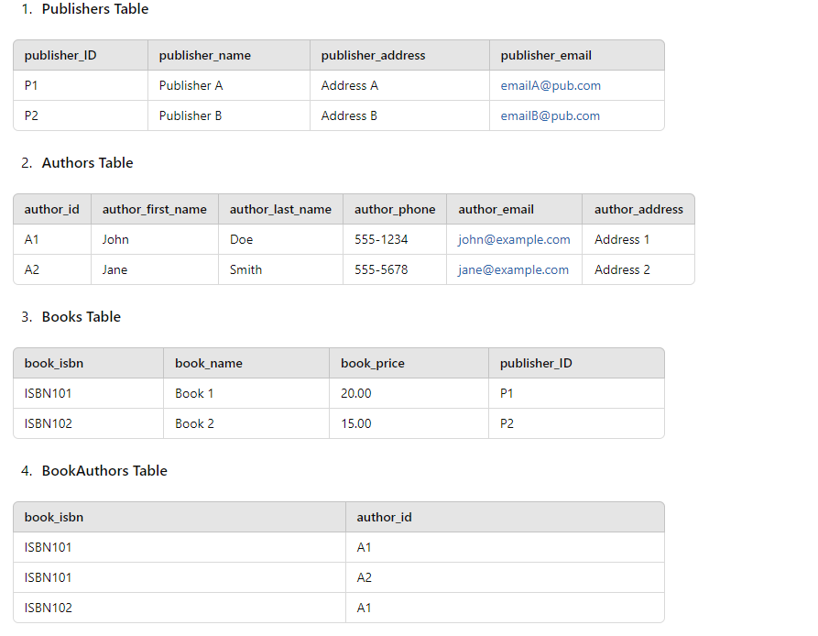

This structure ensures that the database is normalized to 3NF, minimizing redundancy and maintaining data integrity. Plus, this is a helpful way to keep organized for corps and myself, considering the fact that it is all in separate tables.